**Sample MEC Using Expanded Format**

The **Movement Evaluation Continuum (MEC)** is an informal assessment tool used to evaluate functional movement based on three core elements: **Space, Time, and Energy**.

Therapists may choose to use the MEC in two ways:

* **Basic format:** Record scores for Space, Time, and Energy only.
* **Expanded format:** Add clinical detail by incorporating five optional categories to build a more comprehensive movement profile:
  1. **Underlying Skills** — bilateral integration, gravitational insecurity, postural control, laterality, visual-motor coordination, motor planning, gross and fine motor coordination, crossing midline, range of motion.
  2. **Neuromuscular Factors** — movement coordination, joint mobility and stability, muscle power, muscle tone, endurance, reflexes, range of motion, soft tissue integrity.
  3. **Client Factors** — values, beliefs, self-esteem, spirituality, motivation, body image, inhibition, and energy (reflecting the efficient use of physical and mental resources to move, does not fatigue quickly).
  4. **Sensory Processing** — arousal level, tactile, proprioceptive, vestibular, visual, auditory, gustatory, and olfactory processing, arousal, (level of alertness or readiness to respond, ability to stay organized in the task).
  5. **Rhythm-Related Capacities** — timing, tempo control, beat synchronization, rhythmic entrainment, sequencing, auditory-motor integration, auditory rhythmic cueing, sensorimotor timing, and the use of song.

Therapists are encouraged to adapt the MEC flexibly based on the child’s needs and clinical priorities.

**Note:**  
In alignment with the Occupational Therapy Practice Framework (OTPF-4), **Energy** is classified as a client factor. Although not always directly observable, Energy reflects how efficiently a child uses physical and mental resources to move and complete tasks. Stamina, persistence, and consistency during activity provide observable indicators of how Energy is functioning in a child’s performance.

Contents of Paul’s MEC using the more expanded format:

**Initial assessment – 8/20/22**

**Treatment plan created**

**Assessment after two months- 10/20/22**

**Therapist notes**

**Assessment after 4 months – 12/20/22**

**Reflection**

Functional Movement is between 4-7

**Name: Paul Smith Date of Birth: 04/05/2015**

**Underlying Skills:** Decreased gross motor coordination: struggles with skipping, hoping and running. Bilateral Integration is fair.

**Neuromuscular Factors:** Low tone, decreased muscular strength

**Client Factors:** Mom reports Paul is embarrassed by his lack of gross motor skills and often refuses to play with other children unless it is a sit-down activity. With support, Paul can begin an activity (arousal level) but struggles to sustain his energy and “runs out of gas” quickly (low energy level).

**Sensory Processing:** diminished proprioception/body awareness, low arousal level- needs support to initiate movement.

**Rhythm-Related Capacities:** cannot maintain a consistent rhythm during gross motor activities - decreased flow, intermittent interruptions – stops and starts frequently.

**Treatment Plan**

Paul, a cooperative 7-year-old, presents with global movement challenges across all three core elements of the Movement Evaluation Continuum (MEC), scoring 2 in Space (poor spatial organization), 3 in Time (slow movement), and 2 in Energy (reports of fatigue and low energy). Energy in this context refers to a client factor influenced by multiple body systems affecting his ability to sustain physical effort.

In addition, Paul demonstrates deficits across all five MEC-associated categories:

1. **Underlying Skills** – decreased motor coordination and bilateral integration
2. **Neuromuscular Factors** – low muscle tone and reduced strength
3. **Client Factors** – low self-esteem
4. **Sensory Processing** – low arousal level and diminished body awareness
5. **Rhythm** – difficulty maintaining consistent rhythm during gross motor activities, resulting in frequent stops and starts.

**Therapeutic Plan:**  
Intervention will focus on dance and movement-based activities that emphasize spatial orientation, including directionality and navigating paths in space. Weighted props will be incorporated to enhance proprioceptive input, body awareness, and bilateral integration. Rhythmic movement and auditory cues improve timing and coordination, while endurance-based dance activities boost stamina and consistency. Sensory regulation strategies will be embedded throughout sessions to support optimal arousal levels.

A structured Home Exercise Program (HEP) will be provided to Paul's mother, accompanied by periodic progress reports to monitor gains and address any challenges with home program implementation.

**Movement Evaluation Continuum - 10/20/22**

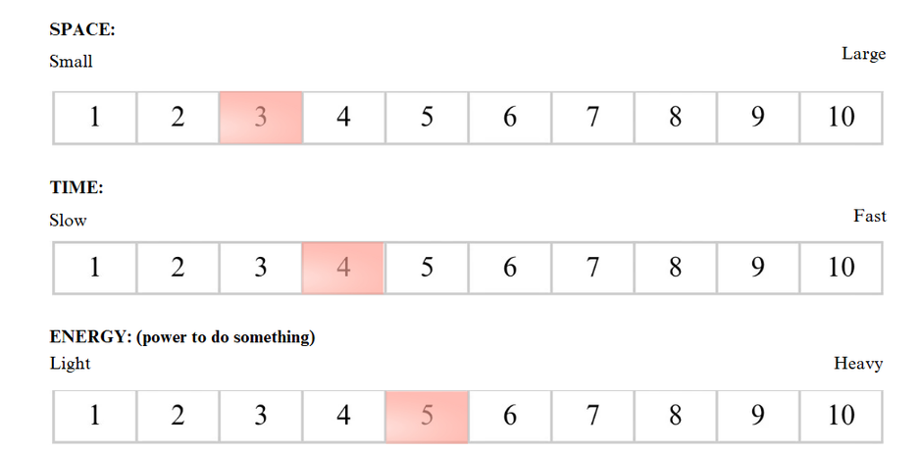

**Functional Movement is between 4-7**

**Underlying Skills:** Exhibits better coordination between the body's right and left sides.

**Neuromuscular Factors:** improved strength and endurance.

**Client Factors:** Paul is beginning to trust his abilities in his sessions with this therapist and likes to show therapist, “what I can do”.

**Sensory Processing:** improved body awareness. Can hold shapes for 10 seconds.

**Rhythm-Related Capacities:** more consistent timing throughout. Therapist has added music to his interventions with positive results

Two-month progress report: Treatment focused on building rapport with the client and addressing his frustration and reluctance towards physical activities. Sessions have been client centered so Paul goes at his own pace.

Improvement noted in all core domains: Space, Time and Energy. There are also improvements in neuromuscular and sensory areas. Paul's arousal level has improved, giving him more energy for his sessions. He is also physically stronger, which positively affects his energy level and ability to sustain activities.

Spatial Orientation (Core Domain: Space) - Dance-like activities have remained mostly in a small area on the floor but use low, middle and high air space. He remains uncomfortable moving out in floor space. Child chooses what music he likes to move to which has had a good effect on his timing and he now demonstrates more consistent use of rhythm.

Paul responds best to a highly structured approach with continual verbal encouragement

**Movement Evaluation Continuum – 12/20/22**

**Functional Movement is between 4-7**

**Name: Paul Smith Date of Birth: 04/05/2015**

**Underlying Skills:** Improved bilateral integration and overall motor coordination.

**Neuromuscular Factors:** Continues to demonstrate more strength and endurance.

**Client Factors:** As per mom, Paul is playing outside with his friends. Last week Paul asked to go the playground. Energy (a client factor) has improved throughout. Therapist encourages Paul through phrases like “go for it”.

**Sensory Processing:** Improved body awareness. Sensory dance activities (using red plastic plates in “The Plate Dance”) help with his arousal level. Attends well when therapist reviews last week's activities before progressing. Responsive to structure, clarity, and repetition.

**Rhythm-Related Capacities:** Good response to activities that include music with a clear beat. Some improvement noted but Paul still struggles with maintaining a consistent tempo.

**Reflection 12/20/22**

**Name: Paul Smith Date of Birth: 04/05/2015**

Paul presents with significant challenges in gross motor coordination, particularly with skills such as skipping, hopping, and running. He scored low across all core elements of the Movement Evaluation Continuum (MEC)—Space, Time, and Energy—and demonstrated delays across all five associated categories. A notable feature of Paul’s profile is his emotional response to these motor challenges. His mother reports frequent feelings of embarrassment and a tendency to avoid active peer interactions, highlighting the psychosocial impact of his motor delays.

**Initial Presentation**  
During the first month of therapy, Paul displayed minimal use of space. His energy level, a factor indicating the body's ability to sustain effort, remained low. Impaired timing further disrupted his coordination. He often appeared sleepy and under-aroused, which limited his participation.

**Therapeutic Approach**  
Given the importance of addressing Paul’s low self-esteem, initial interventions prioritized rapport-building and establishing a safe, emotionally supportive environment for movement-based activities. The therapy space was deliberately uncluttered and inviting. Rather than emphasizing traditional motor tasks, sessions focused on rhythm-based, dance-like movement experiences. Initially, activities required minimal spatial exploration, but over time, Paul was gently encouraged to expand his use of space. He actively participated in selecting music, which fostered engagement and facilitated improvements in speed and timing. Consistent repetition of dance sequences, many incorporating weighted props, supported proprioceptive input and body awareness.

**Progress and Current Status**  
Paul has responded well to small, incremental successes, showing increased participation and enjoyment. He now comfortably traces shapes like triangles and circles with his feet, demonstrating improved spatial orientation and the ability to change directions more fluidly. However, he continues to experience some spatial disorientation in unfamiliar environments outside of the therapy setting.

Currently, Paul demonstrates measurable progress across all three MEC core elements, scoring a "4" in Space, "4" in Time, and "5" in Energy. Although still functioning on the lower end of the continuum, he is making steady gains. Improvements in spatial orientation have led to greater body awareness and better arousal regulation, though he occasionally requires additional support to initiate tasks. Overall, his coordination, strength, and bilateral integration have improved significantly, and both his mother and teacher report growing confidence in peer interactions.

**Family Collaboration and Ongoing Goals**  
Collaborative goals have been established with the family, who receive weekly progress reports to support ongoing home programming. Paul’s mother remains highly engaged and consistent in implementing the home exercise program. With continued therapeutic support, Paul is expected to make further gains in functional motor and movement skills across both home and school settings.